Klondike Derby

Troop 320

February 12 -15, 2016

Bluestone State Park West Virginia

The Rush for Scouting Gold!

C:\Users\ritrev\AppData\Local\Microsoft\Windows\Temporary Internet Files\Content.IE5\LHSTKOZI\MC900229179[1].wmf

Event Handbook

Contents

Welcome 4

Event Details 5

Sleds 6

Event Rules 7

Patrol Equipment List 8

On Your Person 8

On The Sled 8

Event Schedule 9

Patrol Events 11

Challenge locations, activities and times 12

Sled Inspection - Campsite 13

All Knotted Up – Frozen River 14

Building Bridges – Polar Cove 15

Cover Me! – Big Nugget 16

Fishing For Snapper – Big Nugget 17

Norwegian Skiing - Frozen River 18

Trail Injuries – Polar Cove 19

Up the Creek without A Paddle - Fairbanks 20

Which Way Did They Go? - Fairbanks 21

PipeStem Map 23

Klondike Derby 2016 Event Feedback 24

## Welcome

Thank you for attending the 2016 Troop 320 Klondike Derby, The Rush for Scouting Gold! We hope you l have a great time and enjoy how the scouts demonstrate their scouting skills. We hope that all the competition will be friendly and challenging.

We are doing the Klondike Derby in West Virginia. The selected site is BlueStone State Park. The exact campsite will be provided at arrival

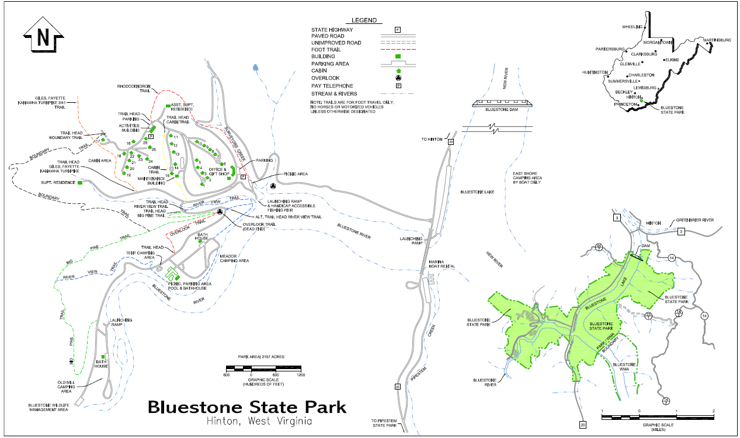

## Event Details

**Date:** February 12-15, 2016

**Location:** Bluestone State Park West Virginia

HC 78 Box 3 Hinton, WV 25951   
(304) 466-2805

**Event Coordinators:** Ricardo Trevino

919- 649-1131 (cell)

919-552-8279 (home)

[trevinoricardo@hotmail.com](mailto:trevinoricardo@hotmail.com)

Tim Brady

919-345-7019 (cell)

919-557-2447 (home)

[Tbrady98@gmail.com](mailto:Tbrady98@gmail.com)

Tim Hoegemeyer

(919) 610-4390 (cell)

[hoegey5@gmail.com](mailto:hoegey5@gmail.com)

**Who can attend?:** All registered Boy Scouts

Parents, relatives and friends

**Cost:** Cabin $170.14 per night (max 12 people)

Website Bluestone <http://www.bluestonesp.com/>

**Directions**: Take exit 139 (Sandstone/Hinton) off Interstate 64 to WV 20 South, and drive 15 miles to the park. From the south on Interstate 77, take the Athens Road Exit (exit 14) to WV 20 North, and travel 22 miles to the park.

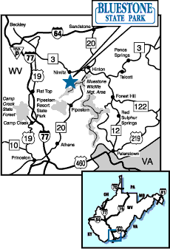

## Sleds

A “sled” or **sleigh** is a land vehicle with a smooth underside or possessing a separate body supported by two or more smooth, relatively narrow, longitudinal **runners** that travels by sliding across a surface. The boys will be pulling and pushing them. They need to be strong and lightweight. It will also be used to carry equipment including patrol and personal gear.

The sled can be made out of a variety of materials or one material but it must be strong. Be creative. If it can be pulled and can transport gear, all is good.

Patrols can get together to build a sled. There are many sled designs on the internet. You can choose whatever you like

If you need skis for your sled, check Craiglist or thrift shops for used skis with your parents help

Please remember, its BOY Scouts. The boys should build the sled, with appropriate adult supervision, of course. Have fun and be safe!

Each patrol can have a maximum of 5 participants

## Event Rules

1. Troops need to bring an adequate supply of water. Plan according to the weather
2. ABSOLUTELY NO GROUND FIRES! Please use the fire pit on your campsite or the big fire pit by the office. Thank you!
3. **No firewood may be brought into camp**. This is a State park rule. A supply of firewood will be available for purchase.
4. No generators, kerosene heaters, potbellied stoves, etc.
5. No more than one vehicle in campsites except to load and unload gear. Troop trailers are permitted.
6. Maximum 1 vehicle at a time per campsite. Please return to the parking lot after unloading.
7. BSA liquid and fuel gas policies must be adhered to at all times.
8. No open flames are permitted in tents.
9. Every patrol must have a sled to participate.
10. Each patrol sled will be inspected for the items on the equipment list.
11. All sleds will be judged for ‘Best Sled’. Decisions will be based on style, decoration, enhancements and originality.
12. All scouts must be properly dressed for the weather. **Each scout will be required to have boots, gloves, jacket, and a hat/hood (appropriate to the weather) to participate in the events**.
13. Adults are encouraged to accompany patrols along the trail but are discouraged from assisting.
14. Please stay on the campsite side of the road at all times between each event. Do not cross the road
15. There will be a 20-minute time limit for each event.
16. The Mayor’s decision is final at each event.
17. No littering. Let’s leave camp cleaner than when you got here.

Most importantly, HAVE FUN!!!

The Klondike 2016 committee has the right to add/amend as deemed necessary

## Patrol Equipment List

Equipment listed below is in addition to your standard winter camping gear.

### On Your Person

Scout Spirit

Patrol Spirit

Ability to have fun

Teamwork

Boots on the feet of each patrol member (old sneakers do NOT count as boots)

Hat and gloves for each patrol member

Suitable outdoor clothing for each patrol member (stay warm & dry)

The required clothing is for your safety and comfort

### On The Sled

1. The sled itself (of course)
2. Rope to pull the sled
3. The following gear must be contained without falling out/off the sled.
   * Enough rope to hang and pull your sled (50’ of 1/4” rope)
   * Boy Scout Handbook
   * Patrol first aid kid (per BSA Handbook)
   * Compass, at least one
   * 1 tarp
   * 6-8 tent stakes
   * One 1-gallon zip-top bag to hold the map and challenges score card you will be given
   * Pencils/pens
   * A teddy bear or similar
   * A hat,
   * A scarf
   * 1 pair old tennis shoes
   * 2 old tennis racquets
   * Yummy snacks for all patrol members
   * A flashlight
   * A magnifier
   * 1 bottle of water for each team member
   * 1 soccer ball or basketball

## Event Schedule

**Friday**

3:30 PM Meet at Mr. Traylor’s farm

4:00 PM Leave to W.V. (We will have dinner at a rest stop)

9:00 PM Arrive at park

9:00 – 9:30 PM Set-up

9:30 – 10:30 PM Cracker Barrel for Scoutmasters review plan and location

10:30 PM Quiet time

**Saturday**

7:00 – 8:30 AM Breakfast – Scout master cooking (yeah!!)

8:30 – 9:45 AM Sled building (competition)

9:45 – 10:00 AM Mayors and Staff - prepare towns

10:00 AM Patrols and sleds to their starting event

10:00 – 12:45 AM Morning events (2 towns)

12:45 – 2:00 PM Lunch – scout master cooking (enjoy!!)

2:15 – 4:45 PM Afternoon events (2 towns)

5:00 – 5:15 PM Clean up

5:15 – 5:30 PM Sled Race

5:30 – 7:00 PM Dinner / free time

7:15 – 9:30 PM Pipestem swimming pool, ping pong and pool table games

10:00- 10:30 PM Feedback session / Awards

11:00 PM Quite Time

**Sunday**

7:00 – 9:00 AM breakfast Scouts cooking

9:00 - 9:45 AM cleanup and pack

10:00 – 10:30 AM worship service – Lookout tower (lead by scouts)

10:45 AM drive back to NC

12:00- 01:00 PM Stop for lunch / Gas

3:35 PM arrive to Mr. Traylor’s farm

## Patrol Events

Starting event positions will be chosen by patrols on a first-come first-served basis.

Upon successful completion of your sled inspection, an open starting event location may be selected. All sleds need to have passed inspection by 9:30 am Saturday to ensure a timely start. All sleds will be placed in the impound area following inspection. They cannot be removed until the patrol proceeds to their starting event location with their sled. The rest of the events should be completed in sequence. Please stay on the trail.

Please respect the maximum time allowed at each event. There will be a maximum of 30 minutes for each event with 10 minutes for travel time between events. If your patrol completes an event early, you may move on to the next event after being released by the Mayor of the town you are at. Please be patient when you arrive at the next event. If there are other patrols there, you may need to wait a bit for staff to be ready for you.

Take note of where you are at each event. It may serve you well later!

At lunch time, patrols should take the sled back to the campsite. Event staff members will return to the campsite for lunch so they will not be able to supervise the patrols during this time. Please be sure your patrols have appropriate adult (2-deep) supervision if they will be using stoves or fires to cook.

# Challenge locations, activities and times

|  |  |  |  |  |  |
| --- | --- | --- | --- | --- | --- |
| Time/Location | **Campsite** | **Frozen River** | **Polar Cove** | **Fairbanks** | **Big Nugget** |
| 8:30 – 10:00 | Sled building |  |  |  |  |
| 10:00 – 11:00 |  | All Knotted up | Building bridges |  |  |
| 11:00 – 12:00 |  | Norwegian | Trail Injuries |  |  |
| 12:00 – 13:00 | Lunch |  |  |  |  |
| 14:00 – 15:00 |  |  |  | Up the creek | Cover me |
| 15:00 – 16:00 |  |  |  | Which way | Fishing |
| 16:00 – 16:30 | Clean up | Clean up | Clean up | Clean up | Clean up |
| 16:30 – 17:00 | Slade race* |  |  |  |  |

* Location TBD

### Sled Building/Inspection - Campsite

**Challenge**

Build your sled. Use proper knots and lashing

Have everything you need for Klondike secured on your sled.

**Procedure**

The patrol will present their sled to the judge for inspection. All required gear, per the equipment list, must be on the sled. Points will be deducted for any items you have to go back to camp to get or do not have.

Gear must be secured, not falling off or out of the sled. Sled must be put together using the correct knots and lashing

The sled must provide a means for all patrol members (except the driver) to participate in pulling the sled. (5 patrol members = 4 rope handles; 6 patrol members = 5 rope handles; etc.)

Following successful completion of inspections, the sled will be placed in an impound area until the start of the events.

**Equipment Needed**

Sled

All required equipment listed on page 8

All patrol members

**Scoring**

**20** Points (maximum) for required patrol equipment, correct knots and lashing

Deduct 1 point for each missing item, incorrect knot or lashing

**10** Points (maximum) for required personal clothing

Deduct 1 point for each patrol member without proper clothing

**30** Points (maximum) for sled design and construction (subjective scoring)

1 -**5** Points for teamwork

1 - **5** Points for patrol spirit

Maximum score -**70**

### All Knotted Up – Frozen River

**Challenge**

Demonstrate basic knot tying skills as quickly as possible.

**Procedure**

Using the rope provided, tie six basic knots as directed. When complete, all six knots will be tied in the rope together.

* Square knot
* Bowline
* Clove hitch
* Sheet bend
* Timber hitch
* Taut line hitch

**Equipment Needed**

None

**Equipment Provided**

Rope

**Scoring**

2 points for each knot tied correctly (maximum **12**)

Maximum twenty (**20**) points, force ranked, based on time. 20 points for 1st, 19for 2nd, 18 for 3rd, etc.

1 -**5** Points for teamwork

1 - **5** Points for patrol spirit

Maximum score -**42**

### Building Bridges – Polar Cove

**Challenge**

Get your sled and all your gear to the other side of the ravine as quickly as possible.

**Procedure**

Using rope from your patrol gear, create a “sling” to suspend your sled and gear from a single attachment point.

Connect your rig to the carabineer provided on the cable.

Using ropes to pull and guide your sled, get everything to the other side.

Scouts may not touch the sled while in transport.

There will be a five-second penalty for each item that falls off the sled.

**Equipment Needed**

Enough rope to hang and pull your sled

**Equipment Provided**

Cable/Rope, carabineer and pulley

**Scoring**

Maximum twenty (**20**) points, force ranked, based on time. 20 points for 1st, 19 for 2nd, 18 for 3rd, etc.

1 -**5** Points for teamwork

1 - **5** Points for patrol spirit

Maximum score -**30**

### Cover Me! – Big Nugget

**Challenge**

Erect an emergency shelter as quickly as possible.

**Procedure**

Erect an emergency shelter large enough to cover your patrol using the gear from your sled.

Use at least three lashings.

Use at least two different types of lashings.

**Equipment Needed**

Everything you need to build an emergency shelter large enough for your patrol

**Equipment Provided**

Space

We need to provide sticks

**Scoring**

Maximum **8** points

Deduct 2 points for each incorrect lashing

Deduct 2 points if two types of lashings are not used

Maximum twenty (**20**) points, force ranked, based on time. 20 points for 1st, 19 for 2nd, 18 for 3rd, etc.

Deduct 1 point for each patrol member not covered

1 -**5** Points for teamwork

1 - **5** Points for patrol spirit

Maximum score -**38** points

### Fishing For Snapper – Big Nugget

**Challenge**

Use the fishing poles and bait provided to catch as many “fish” as you can in the given time limit.

**Procedure**

Patrols will be equipped with bamboo fishing poles baited with nuts and/or washers. Patrols must cast and “catch” at least two “Snappers”. The Scout will be blindfolded and the other scouts will direct the blind scout where the fish are

**Equipment Needed**

None

**Equipment Provided**

Fishing poles & bait (magnets)

Wood fish with a clip

Blindfold

**Scoring**

2 Points for each “Snapper” caught -maximum **10** points

1 -**5** Points for teamwork

1 - **5** Points for patrol spirit

Maximum score -**20**

### Norwegian Skiing - Frozen River

**Challenge**

Demonstrate your ability to work as a team.

**Procedure**

With **all** members of your patrol atop the skis, navigate through the defined course as quickly as possible.

If someone falls off, you must start at the beginning.

**Equipment Needed**

Teamwork and rope

**Equipment Provided**

Skis

Rope?

**Scoring**

Maximum twenty (**20**) points, force ranked, based on time. 20 points for 1st, 19 for 2nd, 18 for 3rd, etc.

1 -**5** Points for teamwork

1 - **5** Points for patrol spirit

Maximum score -**30** points

### Trail Injuries – Polar Cove

**Challenge**

Demonstrate basic first aid.

**Procedure**

For each scenario presented, define the ailment, describe the symptoms and explain the proper treatment.

Scenarios:

1. Hypothermia
2. Frost Bite
3. Broken leg. Simulate one of the scouts has a broken leg. Then act accordingly as it if was a real injure and transport him and all the equipment to the next event

**Equipment Needed**

Boy Scout Handbook

Patrol first aid kid

**Equipment Provided**

None

**Scoring**

Maximum 10 points per scenario (**40** points total)

Deduct 1 point for each wrong answer

1 -**5** Points for teamwork

1 - **5** Points for patrol spirit

Maximum score -**50** points

### Up the Creek without A Paddle - Fairbanks

**Challenge**

Rescue your patrol member from the chilling Yukon waters as quickly as possible.

**Procedure**

One member of the patrol will be placed on a “floating piece of ice” (sled or tube) and placed 30’ from the “edge”.

Using rope from your sled, coil and toss the rope to your patrol mate.

The patrol member must tie the correct rescue knot.

The rest of the patrol will then carefully pull them to safety.

There will be a 30-second penalty if the incorrect safety knot is used.

**Equipment Needed**

50’ of 1/4” rope

**Equipment Provided**

None

**Scoring**

Maximum twenty (**20**) points, force ranked, based on time. 20 points for 1st, 19 for 2nd, 18 for 3rd, etc.

1 -**5** Points for teamwork

1 - **5** Points for patrol spirit

Maximum score -**30**

### Which Way Did They Go? - Fairbanks

**Challenge**

Demonstrate your ability to use a compass.

**Procedure**

Navigate the course using the coordinates provided as quickly as possible.

See compass document for instruction on how to setup)

**Equipment Needed**

Compass

Pencil

**Equipment Provided**

Course coordinates card

**Scoring**

Maximum twenty (**20**) points, force ranked, based on time. 20 points for 1st, 19 for 2nd, 18 for 3rd, etc.

Deduct 1 point for each incorrect point along the way.

1 -**5** Points for teamwork

1 **- 5** Points for patrol spirit

Maximum score -**30** points

## PipeStem Map

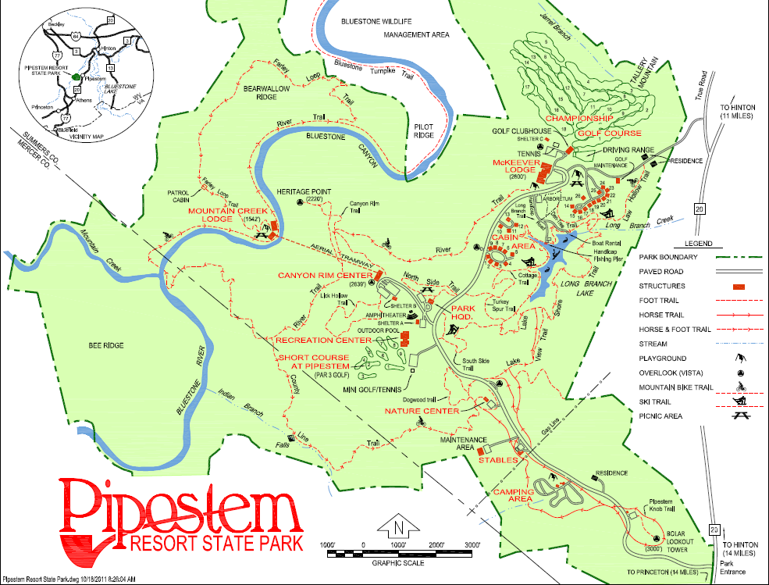

## Klondike Derby 2016 Event Feedback

What events did you like the most? and Why?

__________________________________________________________________________________

__________________________________________________________________________________

__________________________________________________________________________________

What events did you like the least? and Why?

__________________________________________________________________________________

__________________________________________________________________________________

__________________________________________________________________________________

Please comment on how the individual events were organized and run.

__________________________________________________________________________________

__________________________________________________________________________________

Please comment on how the event as a whole was organized and run.

__________________________________________________________________________________

__________________________________________________________________________________

Will you consider attending the next Klondike Derby? Why or why not?

__________________________________________________________________________________

__________________________________________________________________________________

(Optional) Name: __________________________________________________________________